# **Calculus Collated Past Papers – SVA Conversions**

2020 Question 1e.

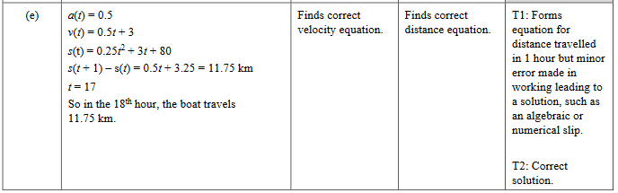

2020 Question 2c.

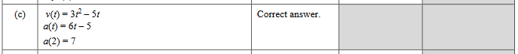

2019 Question 2e.

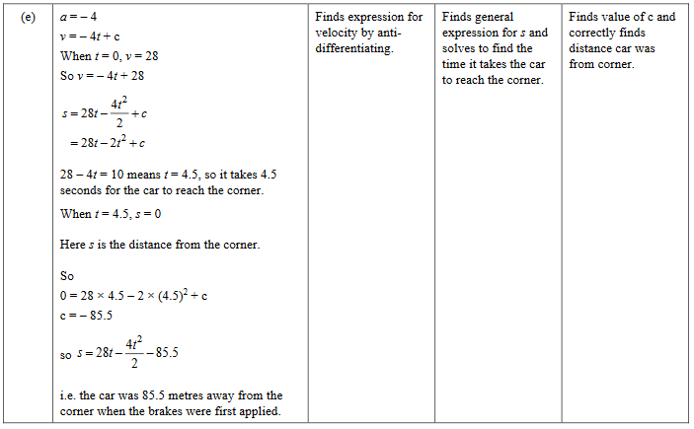

2019 Question 3a.



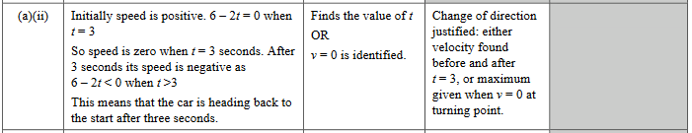

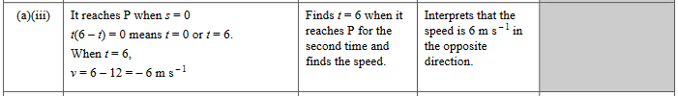

2018 Question 2c.

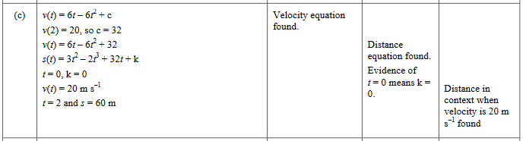

2017 Question 1c.

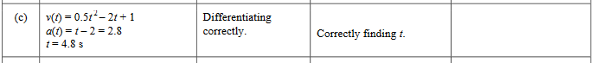

2017 Question 3c.

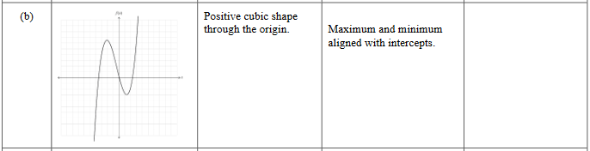

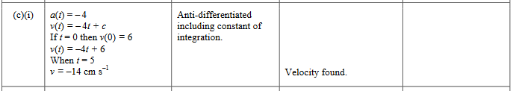

2016 Question 3c.

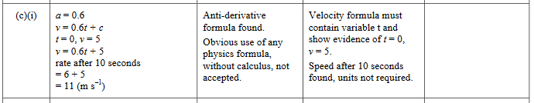

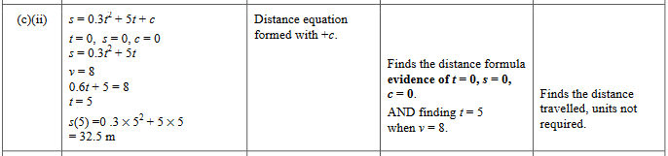

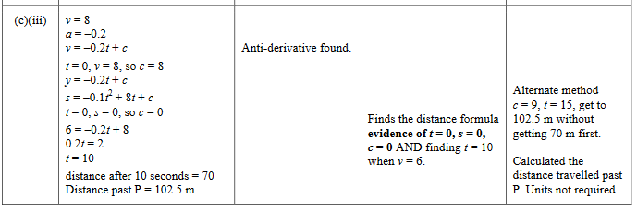

2015 Question 1d.

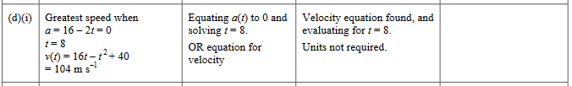

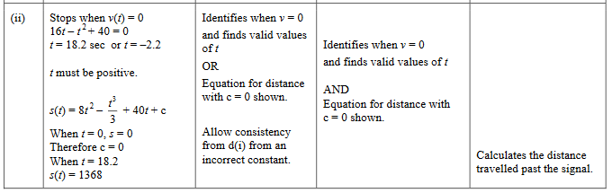

2015 Question 3a.



2014 Question 1f.

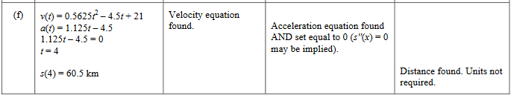

2013 Question 2f.

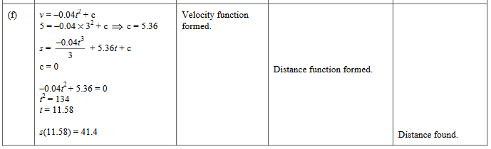

2012 Question 1e.

