# **Calculus Collated Past Papers – Finding Tangent Equations**

2023 Question 2b.

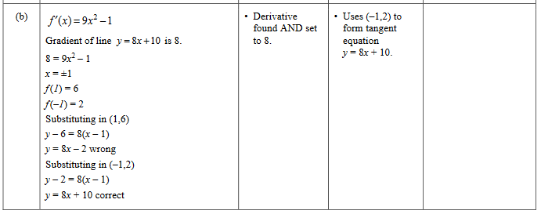

2023 Question 3c.

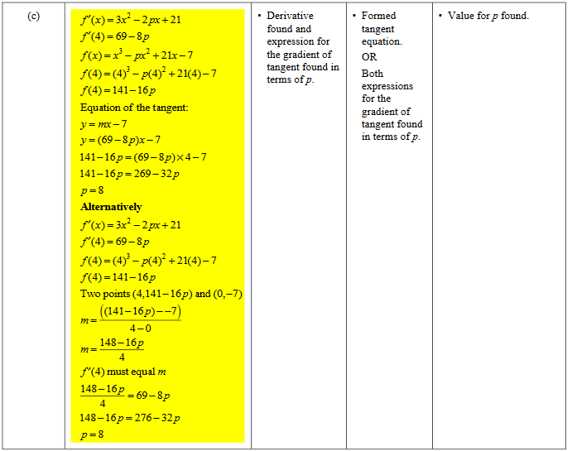

2022 Question 1d.

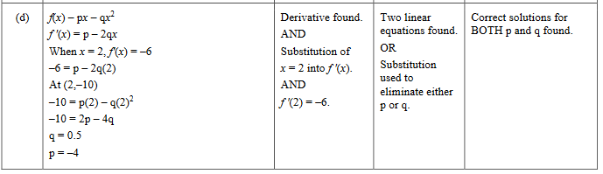

2022 Question 3a.

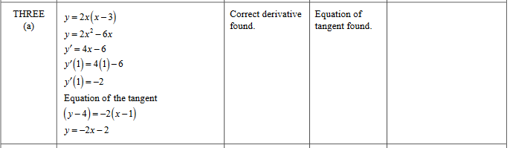

2021 Question 1b.

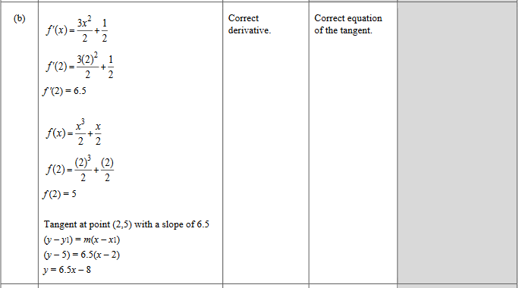

2020 Question 1c.

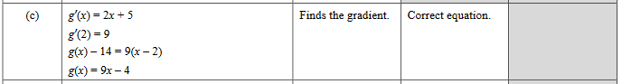

2019 Question 1b.

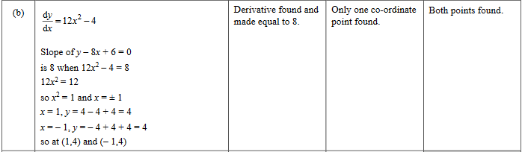

2019 Question 1e.

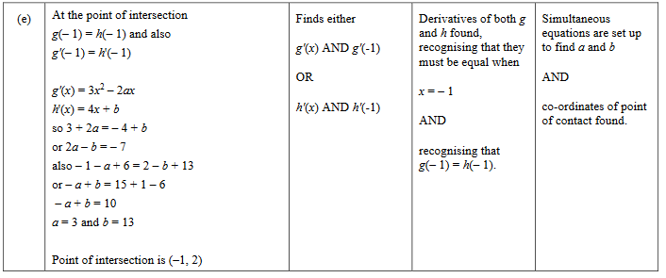

2019 Question 3c.

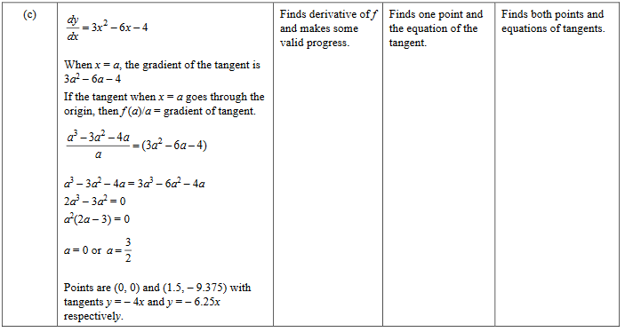

2018 Question 3d.

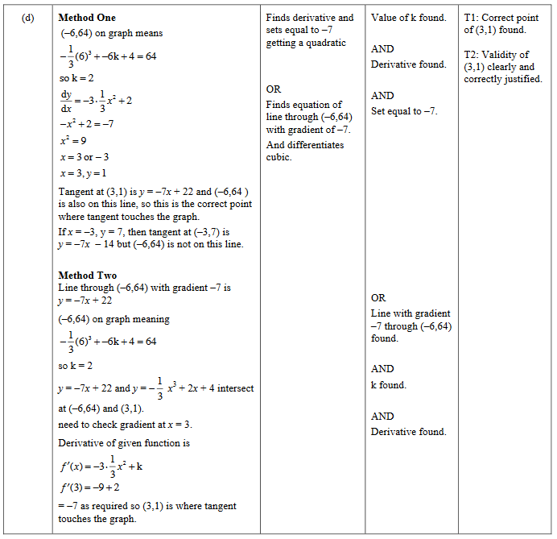

2017 Question 1b.

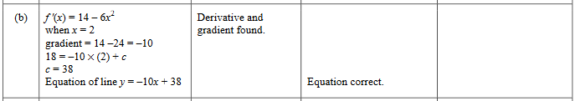

2017 Question 1d.

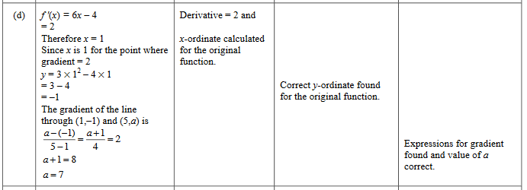

2017 Question 2c.

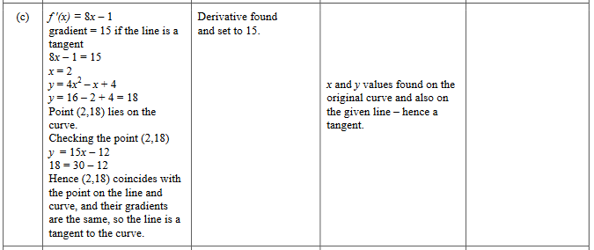

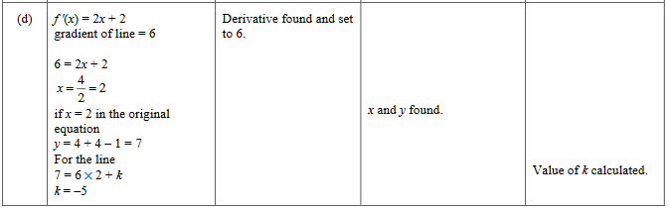

2016 Question 1b.

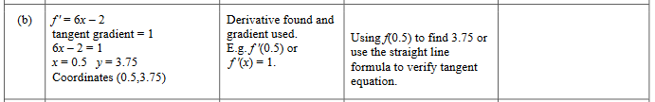

2016 Question 2b.

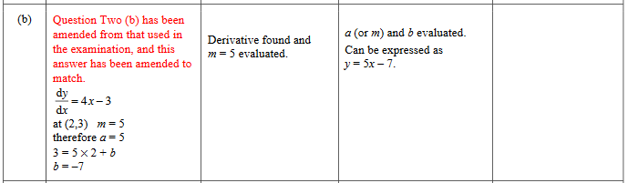

2015 Question 2b.

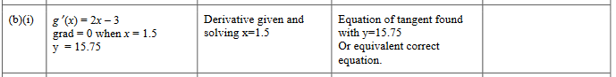

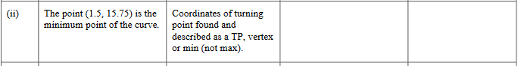

2015 Question 3b.

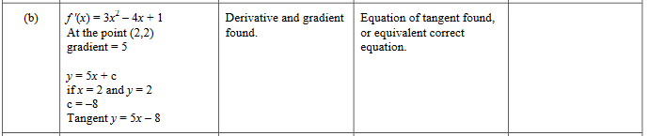

2014 Question 2f.

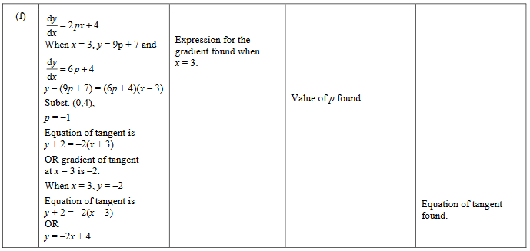

2013 Question 3b.

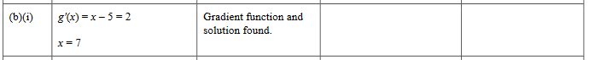

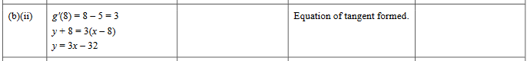

2012 Question 3d.

