# **Algebra Collated Past Papers - Algebraic Manipulation**

2023 Question 1b.

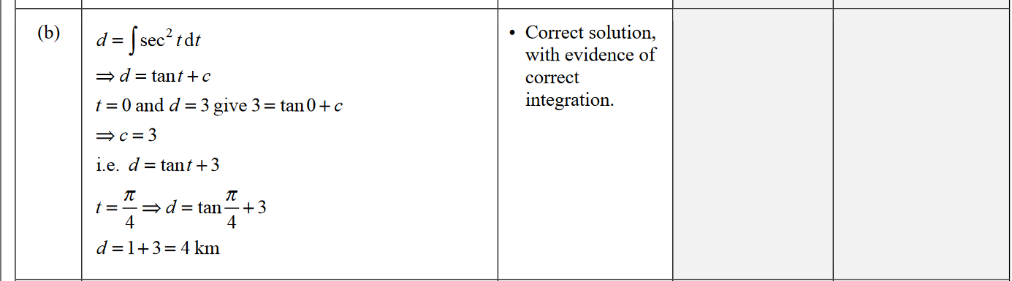

2023 Question 3d.

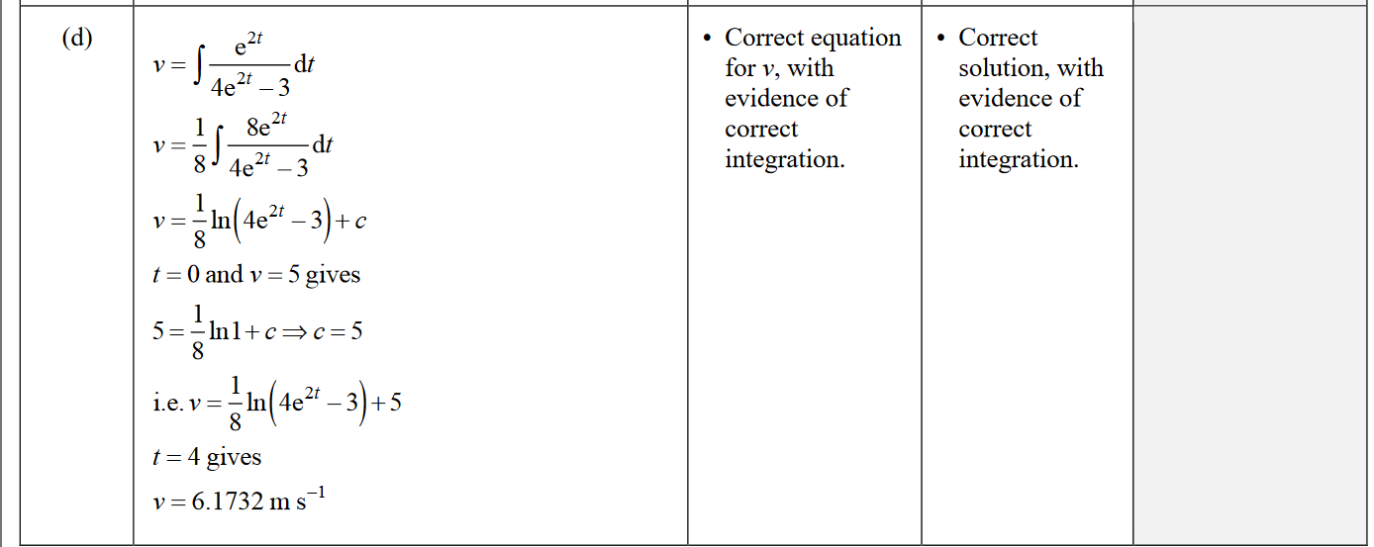

2022 Question 2d.

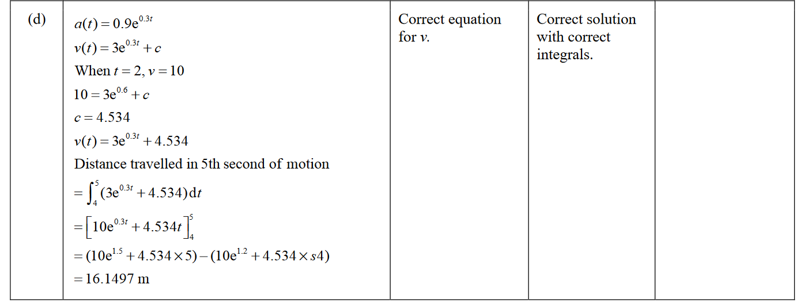

2021 Question 1d.

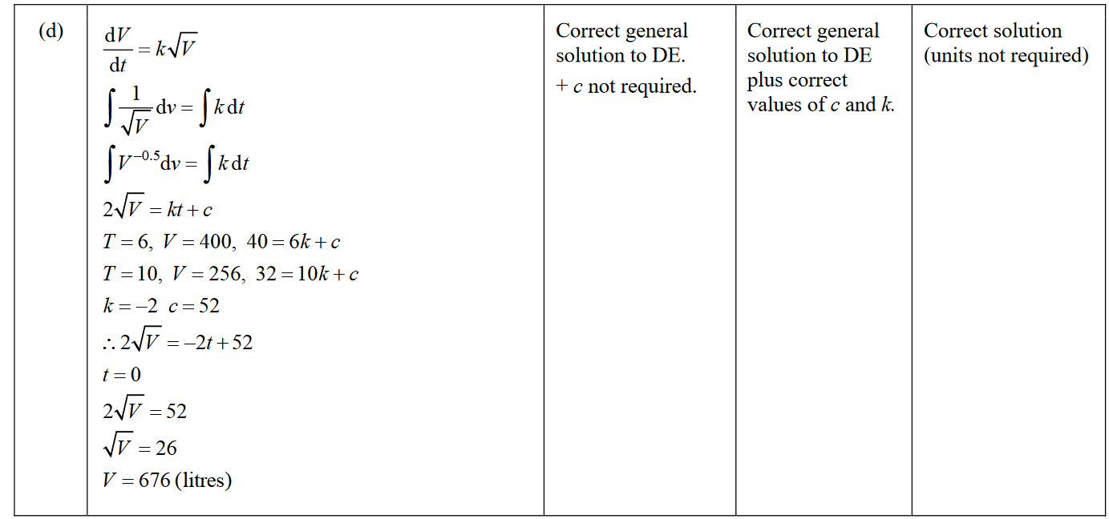

2020 Question 1b.

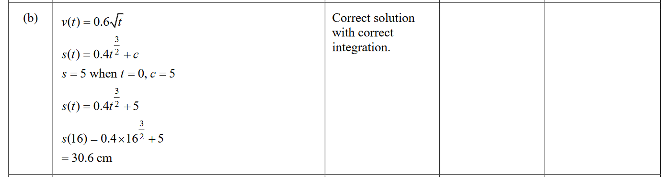

2020 Question 3c.

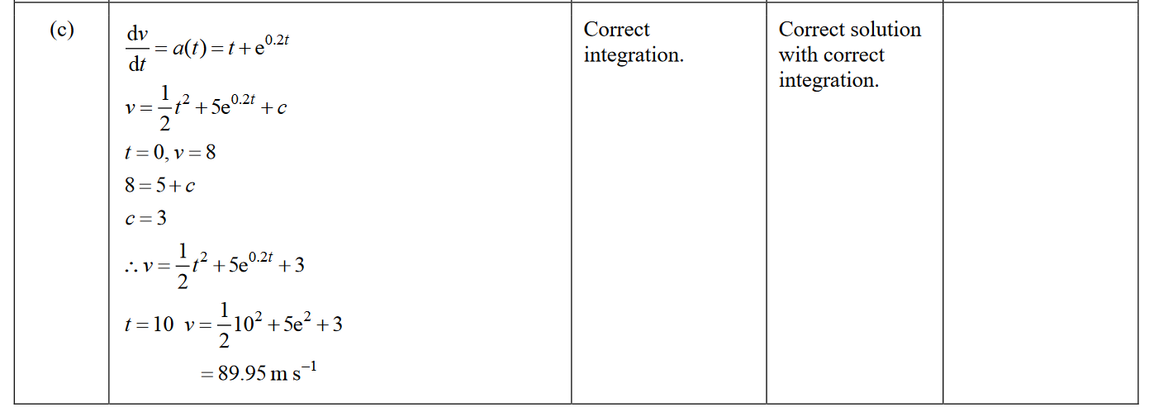

2020 Question 3d.

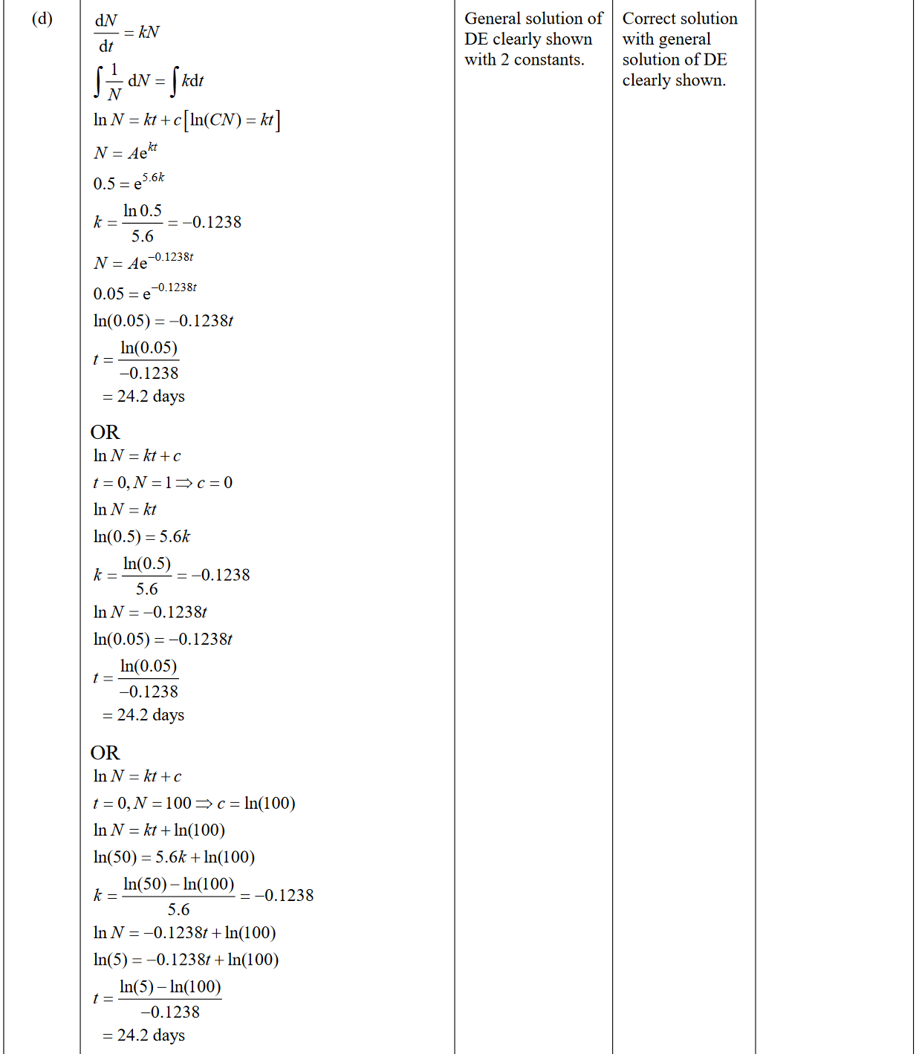

2019 Question 3e.

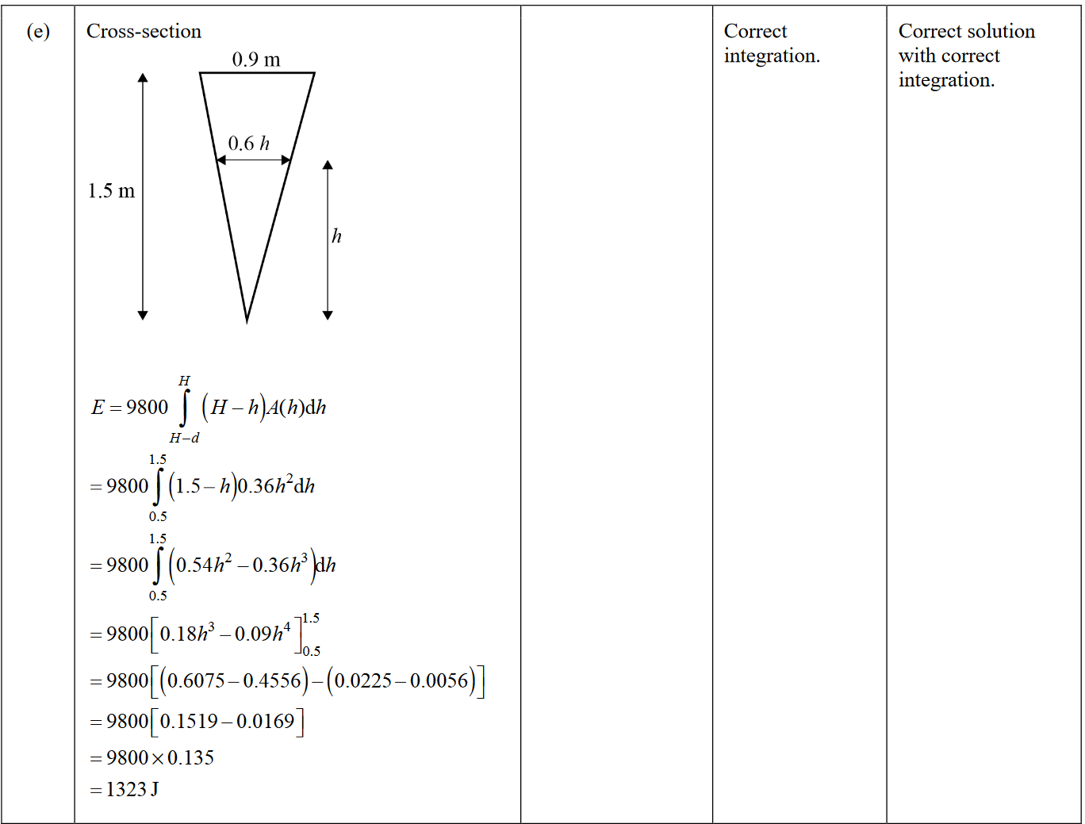

2018 Question 2d.

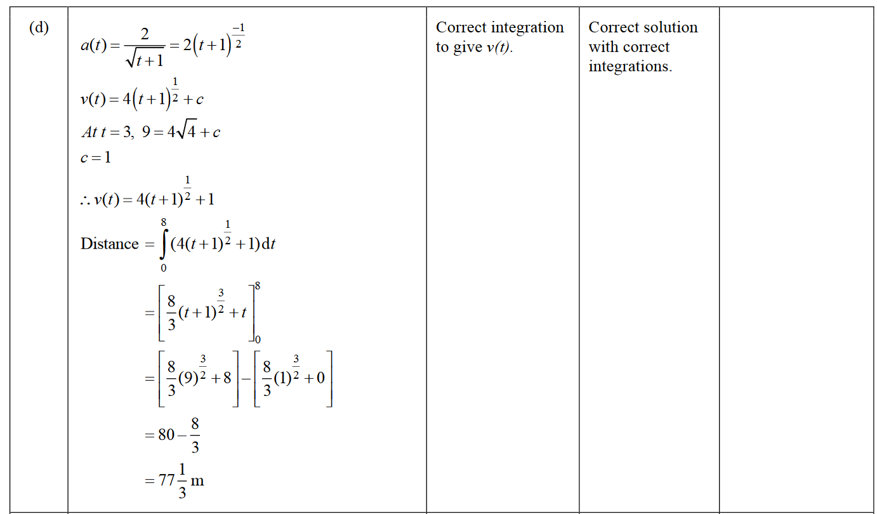

2018 Question 2e.

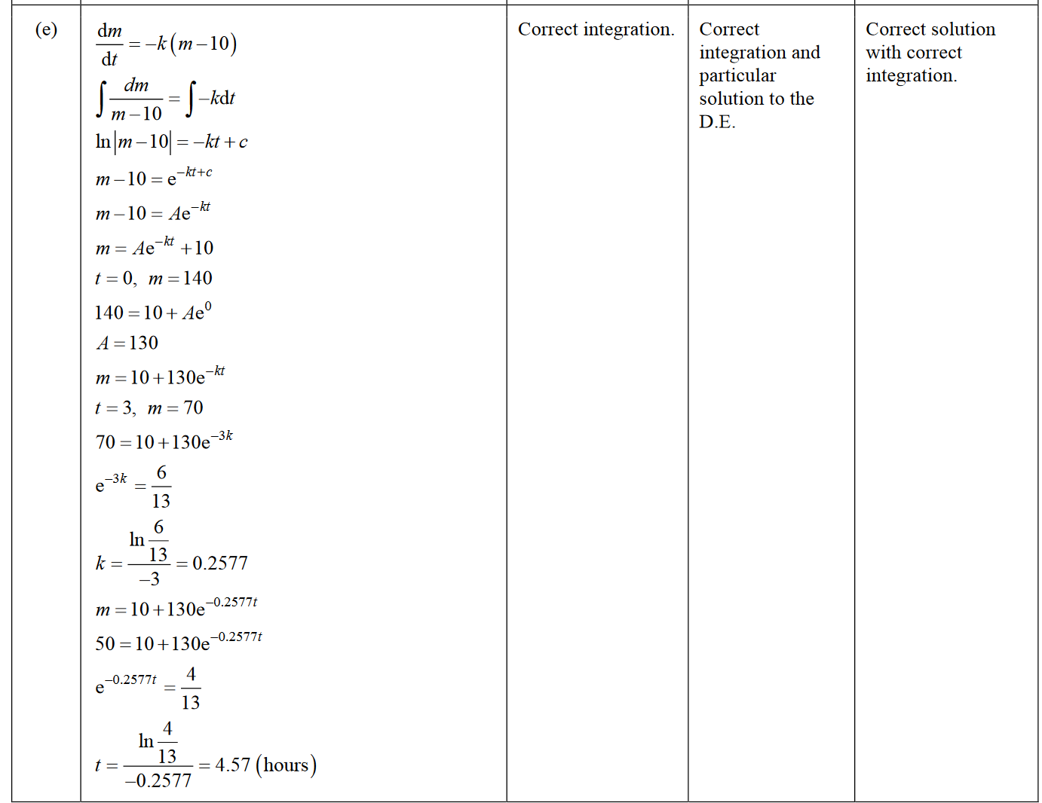

2017 Question 1c.

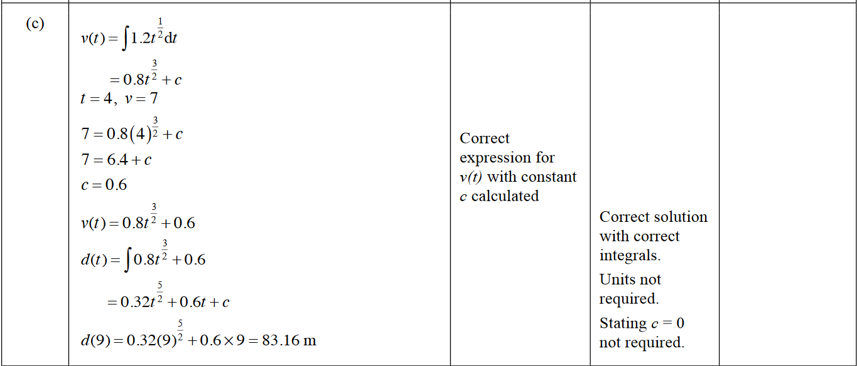

2017 Question 1e.

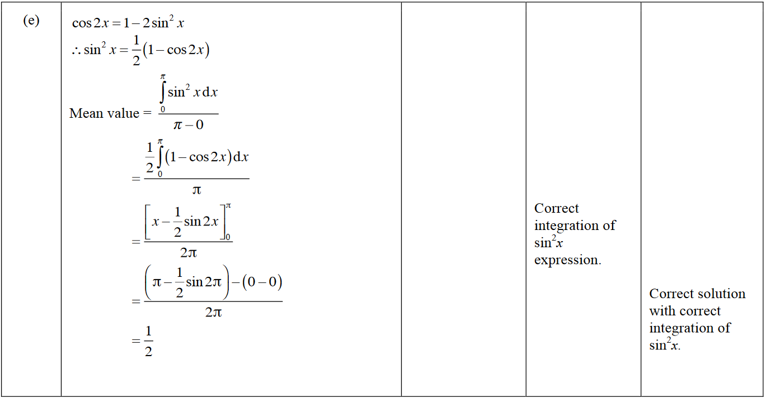

2017 Question 2e.

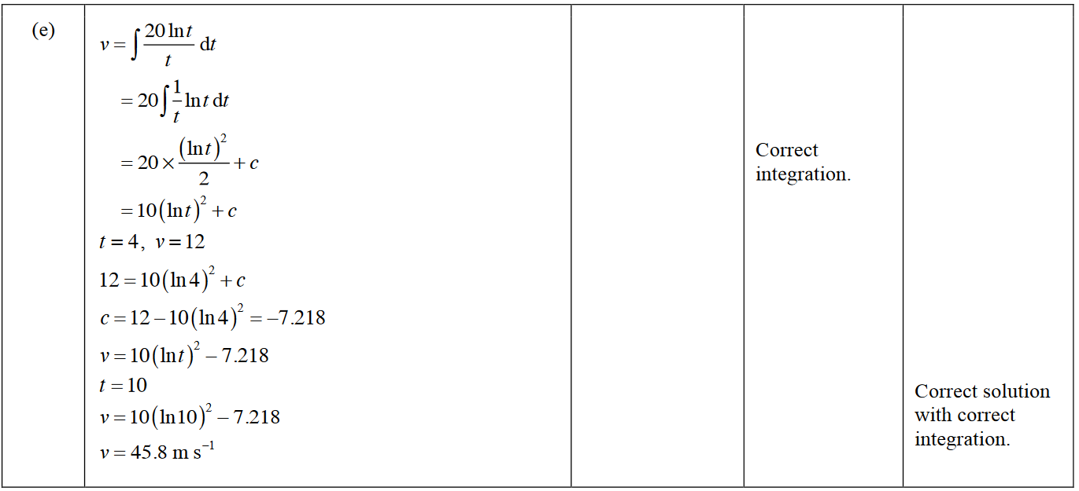

2016 Question 1e.

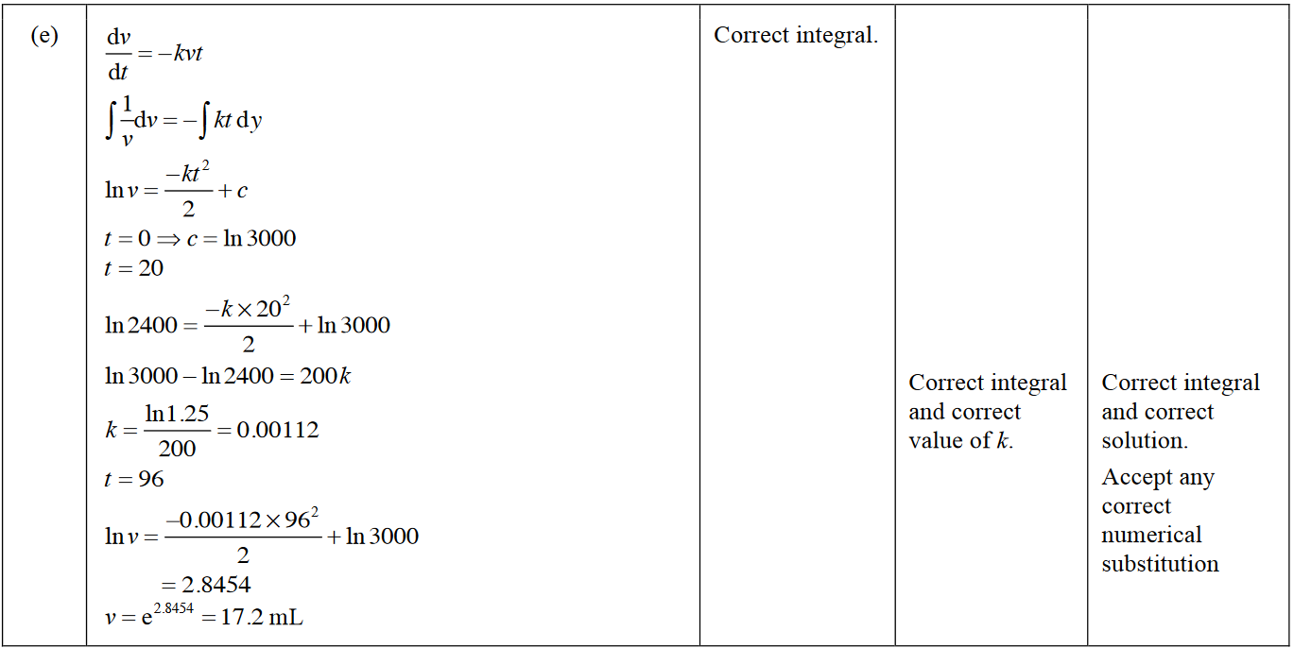

2016 Question 2c.

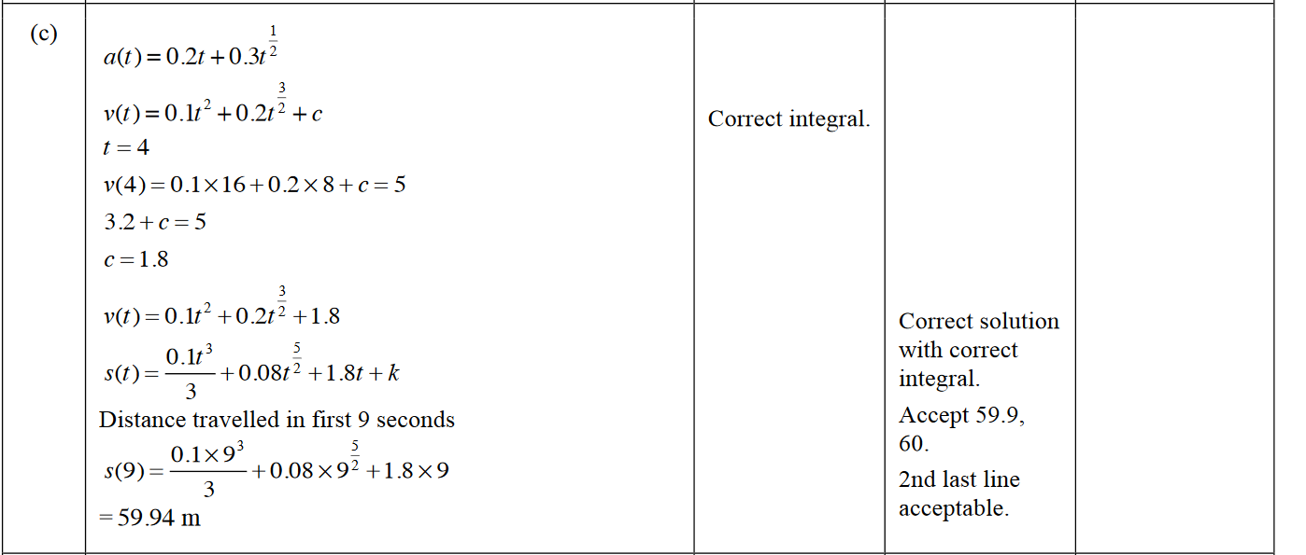

2015 Question 2c.

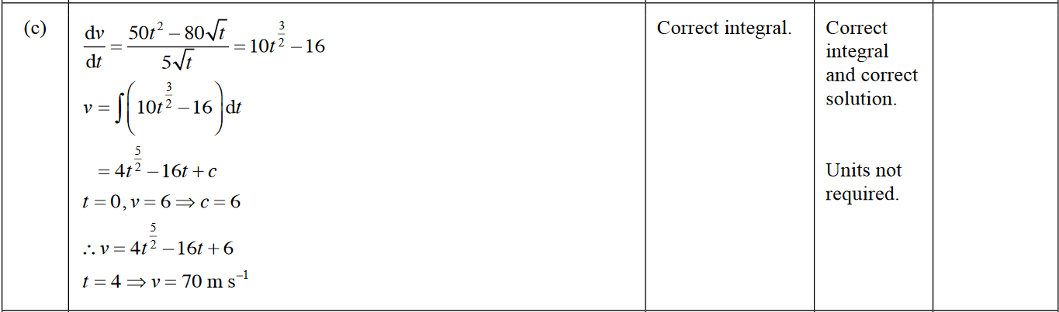

2015 Question 3e.

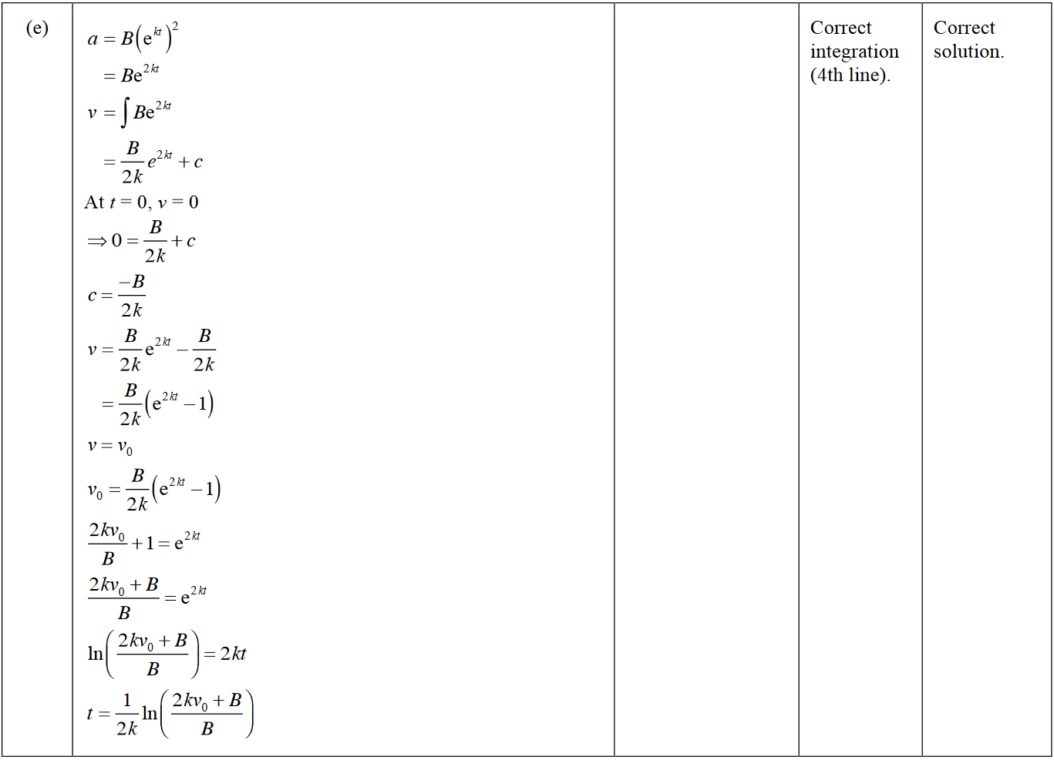

2014 Question 1c.

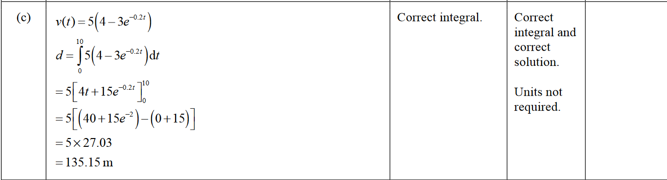

2014 Question 1d.

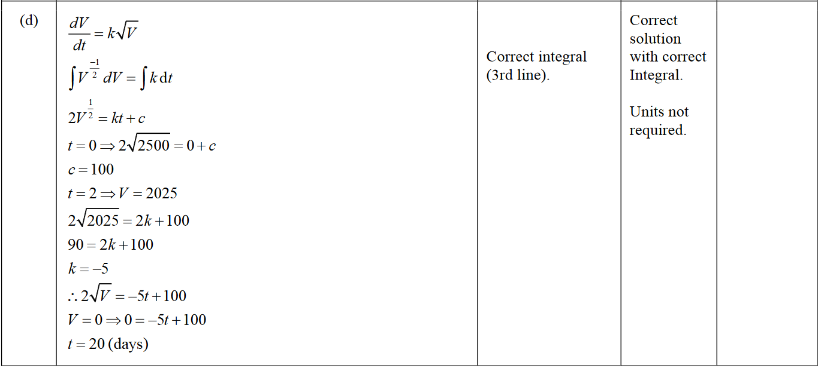

2014 Question 2e.

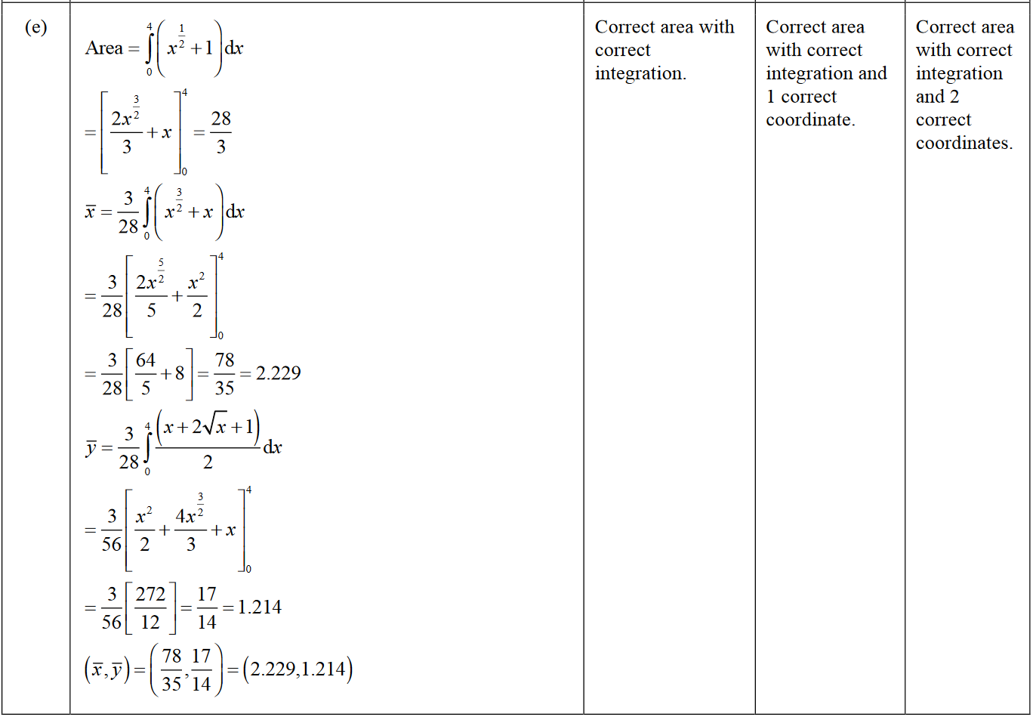

2014 Question 3e.

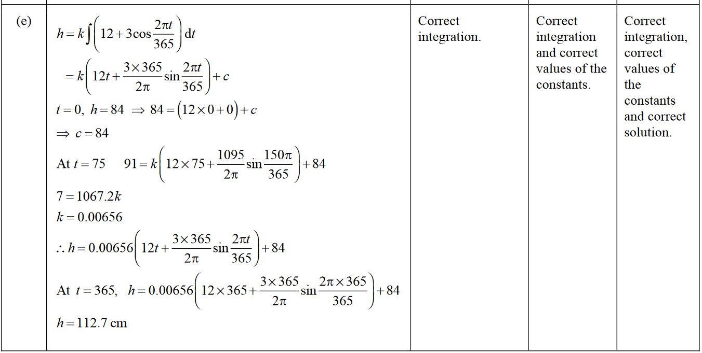

2013 Question 1c.

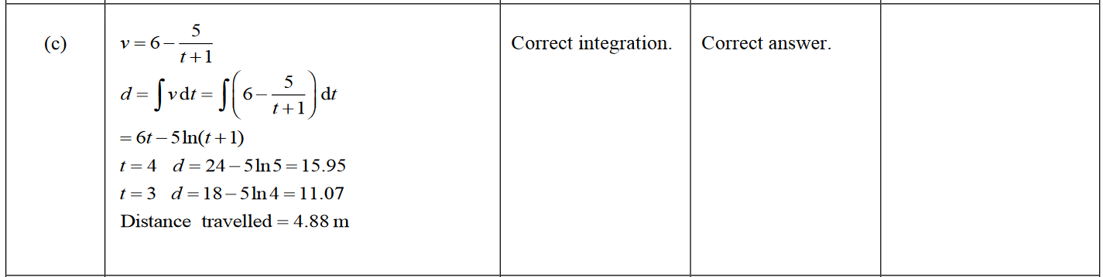

2013 Question 1e.

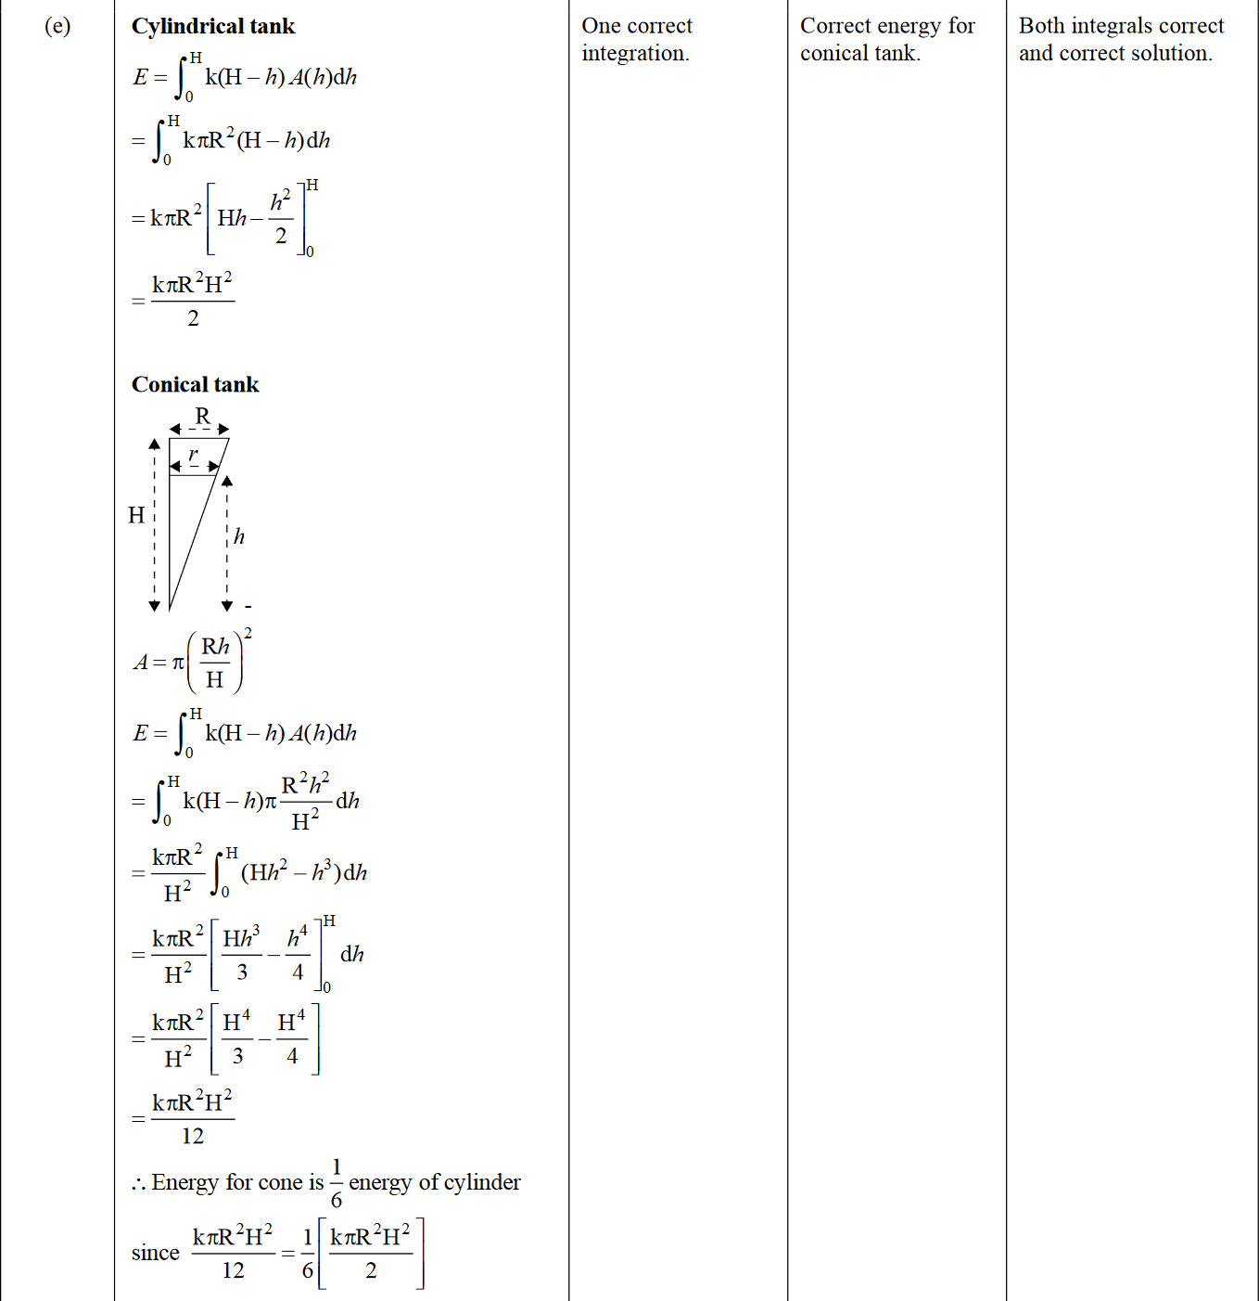

2013 Question 2d.

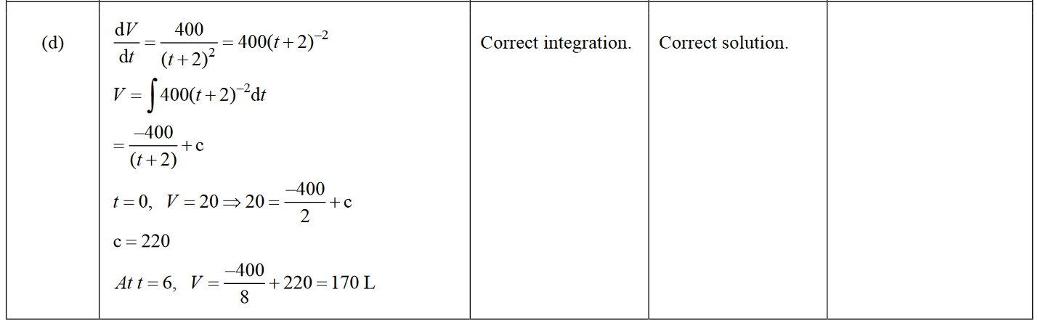

2013 Question 3d.

