# **Algebra Collated Past Papers - Algebraic Manipulation**

2023 Question 1c.

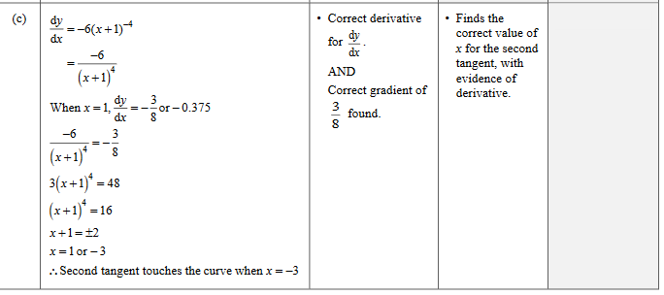

2023 Question 1d.

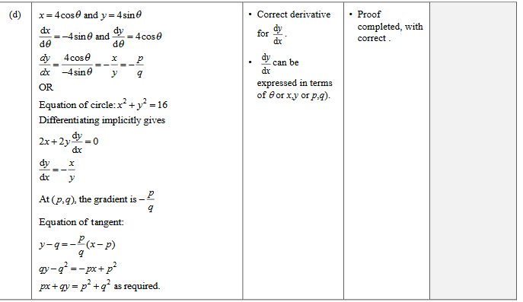

2023 Question 2c.

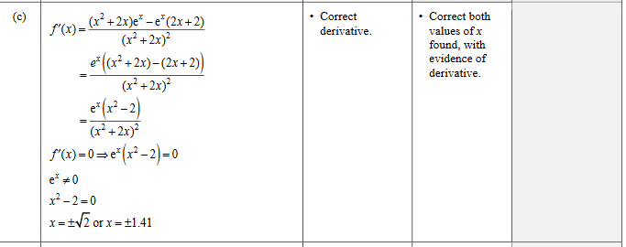

2023 Question 3c.

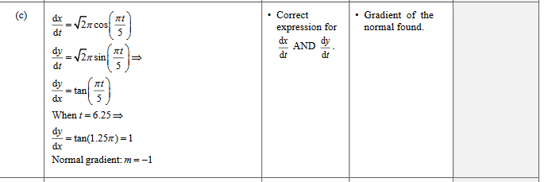

2022 Question 1c.

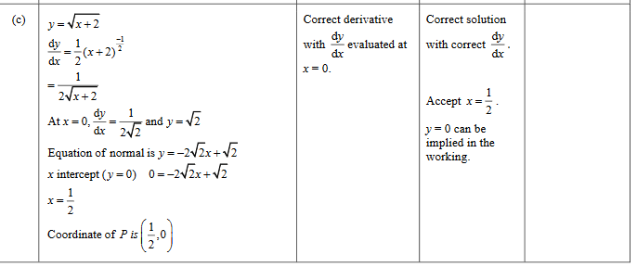

2022 Question 2b.

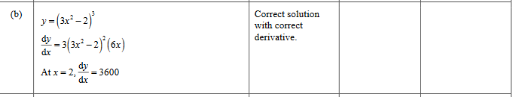

2022 Question 2e.

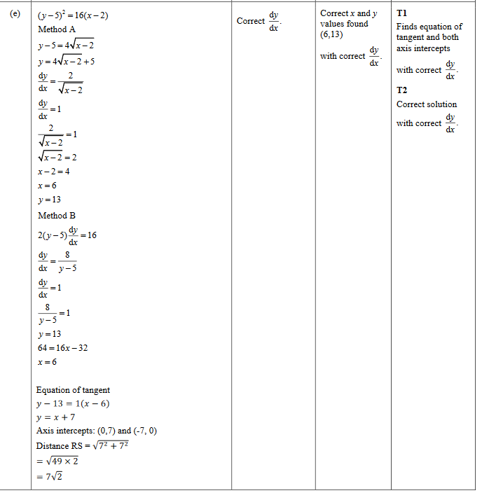

2021 Question 2c.

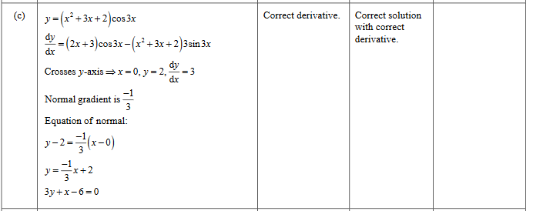

2021 Question 2e.

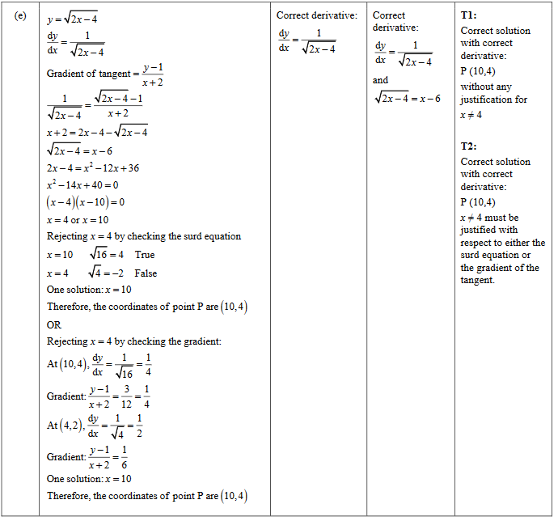

2021 Question 3b.

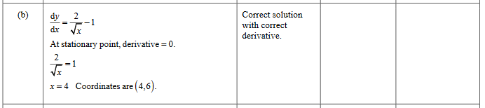

2021 Question 3d.

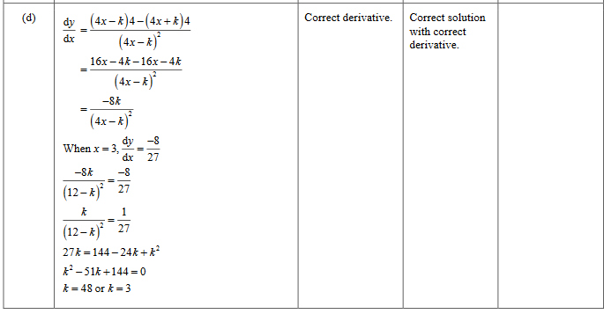

2020 Question 1b.

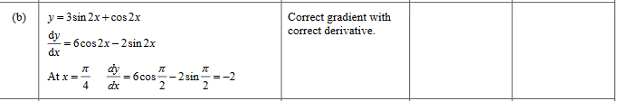

2020 Question 1d.

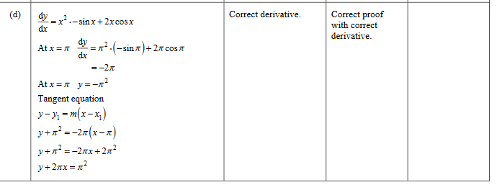

2020 Question 3b.

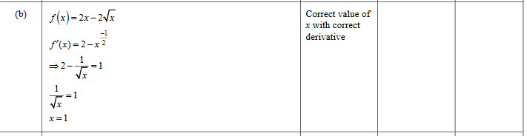

2020 Question 3c.

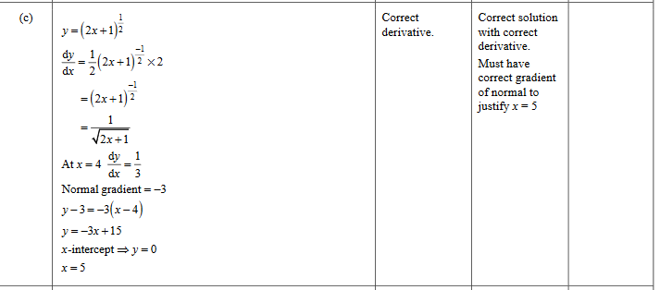

2019 Question 1c.

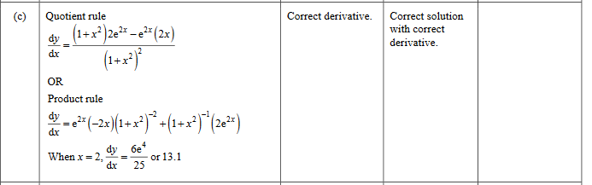

2019 Question 3e.

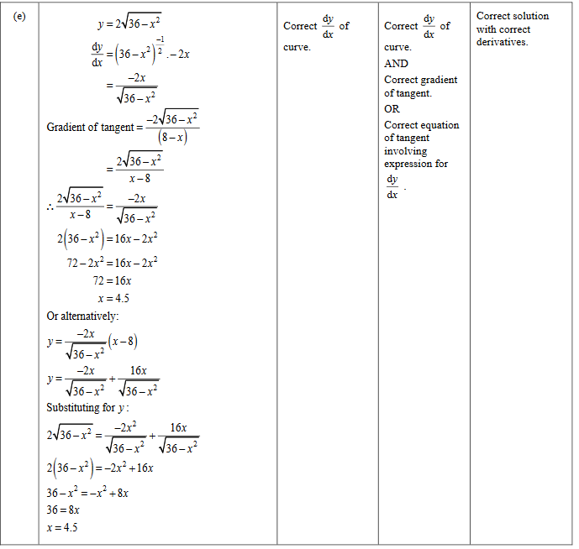

2018 Question 3d.

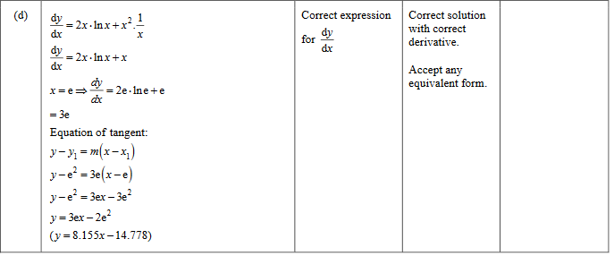

2017 Question 1b.

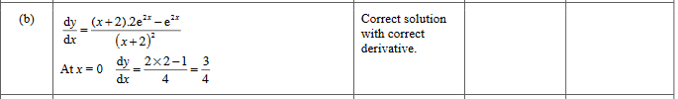

2017 Question 1c.

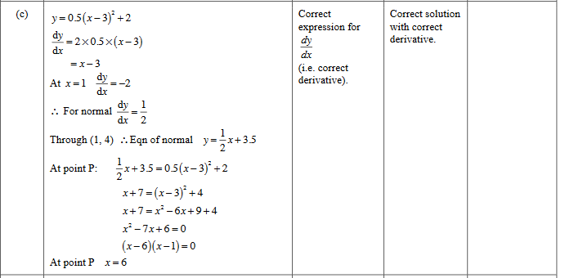

2017 Question 2c.

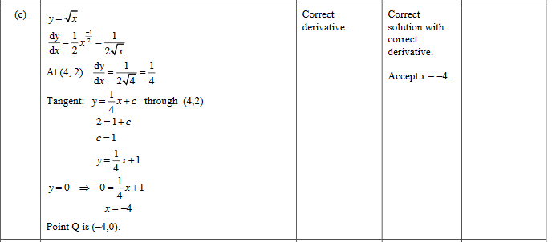

2016 Question 1d.

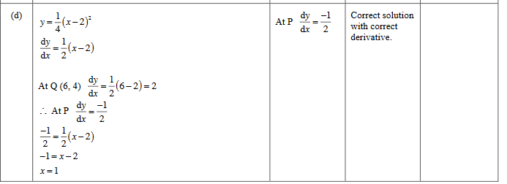

2016 Question 2b.

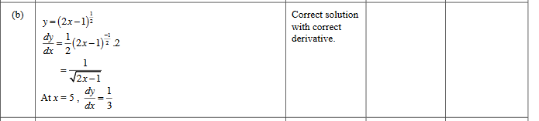

2016 Question 3b.

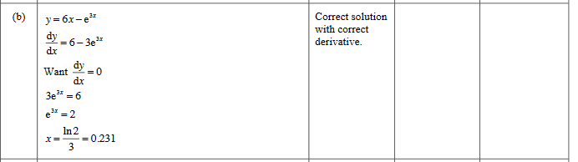

2015 Question 1b.

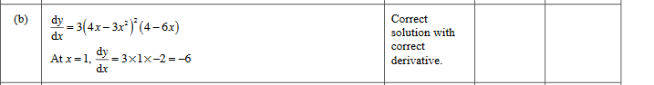

2015 Question 1d.

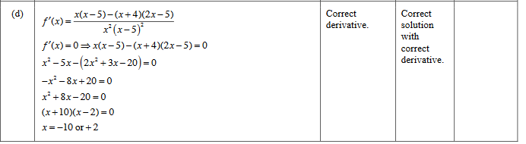

2015 Question 2b.

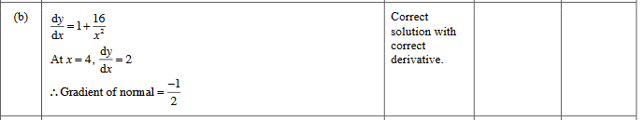

2015 Question 3a.

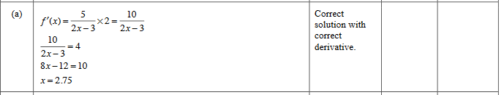

2014 Question 1b.

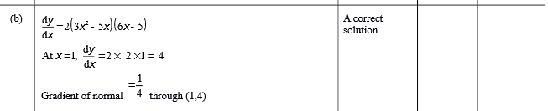

2014 Question 1d.

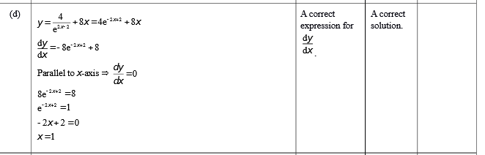

2013 Question 2b.

