# **Algebra Collated Past Papers - Algebraic Manipulation**

2023 Question 1d.

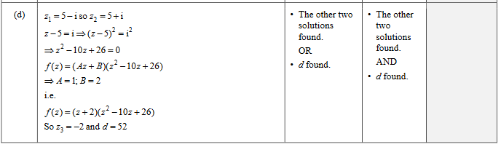

2022 Question 2c.

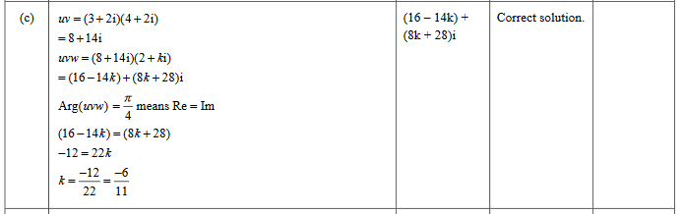

2021 Question 3c.

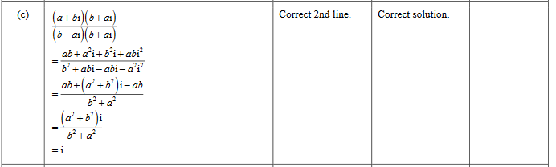

2020 Question 2c.

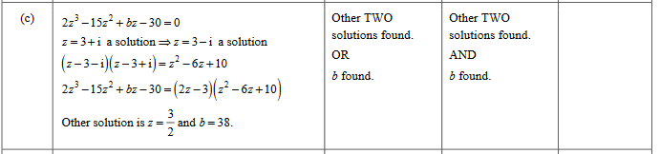

2019 Question 1d.

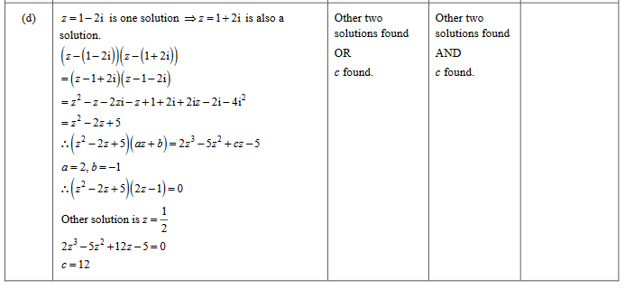

2018 Question 2c.\

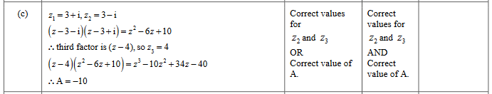

2017 Question 1d.

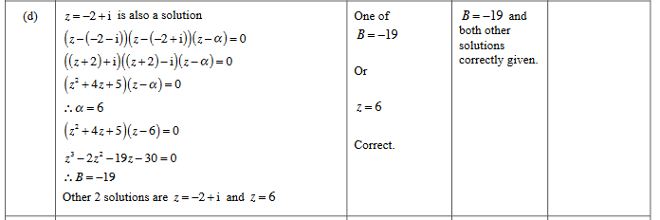

2016 Question 3c.

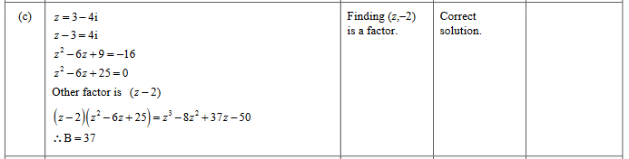

2015 Question 3c.

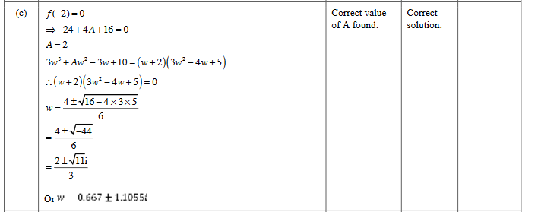

2014 Question 2c.

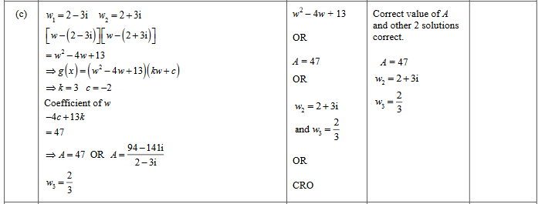

2013 Question 1c.

